INTRODUCTION

Shree Builders and Developers have always strived for benchmark quality, customer centric approach, robust engineering, timeless values and transparency in all spheres of business conduct, which have contributed in making it a preferred developer in Bangalore.

Shree Builders and Developers is primarily focused on residential multi-dwelling and independent residential projects. The Company’s residential projects include premium apartments, villas, and luxury apartments, plotted development and homes replete with state of the art amenities. In all its residential projects, the company lays a strong emphasis on environmental management, water harvesting and high safety standards.

One of the well-respected brands in the real estate sector, Shree Builders and Developers has many distinctions to its credit, mainly its impeccable execution and on-time delivery track record.

Shree Builders and Developers have completed real estate projects and contractual projects. The backward integration model is one of the key competitive strengths of Shree Builders and Developers. This ensures that the Company has control not only over the supply but more importantly over the quality of the materials it uses in construction activities. Shree Builders and Developers have all the competencies and resources to deliver a project from conceptualization to completion.

Shree Builders and Developers as an organization is highly focused on delivering international quality products in a timely manner with utmost perfection.
The leadership of Shree Builders and Developers consists of individuals with over 36 years of combined construction Engineering and management experience. The leaders of Shree Builders and Developers had all studied and practiced together at one point in time or another in their careers prior to joining forces at Shree Builders and Developers. Whether together or apart, we realized that we were all sharing the common principles of providing top notch service to our clients in an honest and trustworthy manner. After many years of obtaining a wide variety of experience in different locations, we decided to join forces to create an elite team of engineers who are capable of being a one stop shop for your real estate development needs.

 |  |  | O R G A N I S A T I O N
1. | NAME | Shree Builders and Developers
2. | ADDRESS | No.6, K.E.B. Layout, Kathriguppe Main Road,
 |  | Vivekananda Nagar, Bangalore – 560085
 |  | Karnataka State,
 |  | India
3. | TELEPHONE Nos. | Mobile No. +91 9900093978
4. | EMAIL ADDRESS | info@shreebnd.com
5. | WEBSITE | http://shreebnd.com
6. | GST | 29ACHFS0448P1ZG
7. | PROPRIETOR | T.N.MANJUNATHA
8. | PARTNER/STRUCTURAL | T KRISHNAMURTHY
 | ENGINEER
9. | PARTNERS | SHARATH BABU, BALAJI, PRASAD.C.N
10. | MARKETING HEAD | PRASAD.C.N

COMPLETED PROJECTS

SL | PROJECT NAME | TYPE OF UNITS | ADDRESS
NO.
1. | SVR Platinum | 2 B HK - 15 units | 4th cross, Ananthanagar - 2n d phase,
 |  |  | electronic city- Phase 2, Bangalore.
2. | SVR Comforts | 2 B HK - 35 units | 10th cross, Ananthanagar - 2 nd phase,
 |  |  | electronic city- Phase 2, Bangalore.
3. | Sree Pranathi Gardens | 2 B HK - 40 units | Vallaba nagar, Vasanthapura main road  Bangalore
 | SVR Deluxe | 2 B HK - 15 units | 9th cross, Ananthanagar - 2n d phase,
 |  |  | electronic city- Phase 2, Bangalore.
4.
 | SVR Kutiram | 2 B HK - 15 units | 10th cross, Ananthanagar - 2 nd phase,
 |  |  | electronic city- Phase 2, Bangalore.
5.
 | SREE PRANATHI | 2 B HK - 40 units | Vallaba nagar, Vasanthapura main road,
 | GARDENS |  | Bangalore
6.
 | Jeevan Jyothi - Phase 1 (Vismaya developers) | 148 sites | Maidahanahalli village, Yelawala hobli, Mysore
7.
8. | Sahiti elegance | 2 B HK - 50 units | 14th cross, Ananthanagar - 2n d phase, electronic city- Phase 2, Bangalore.
9. | Shree Palace | 2,3BHK – 50units | #4,Electronic city Phase-1,Gollahalli,Bangalore-560100
10. | Shree Sai Palace | 2,3BHK – 40 units | Doddakallasandra, Kanakapura main road, Bangalore

FOLLOWING ARE FEW OF OUR PREMIUM DEVELOPMENT MARKETING BROCH URES
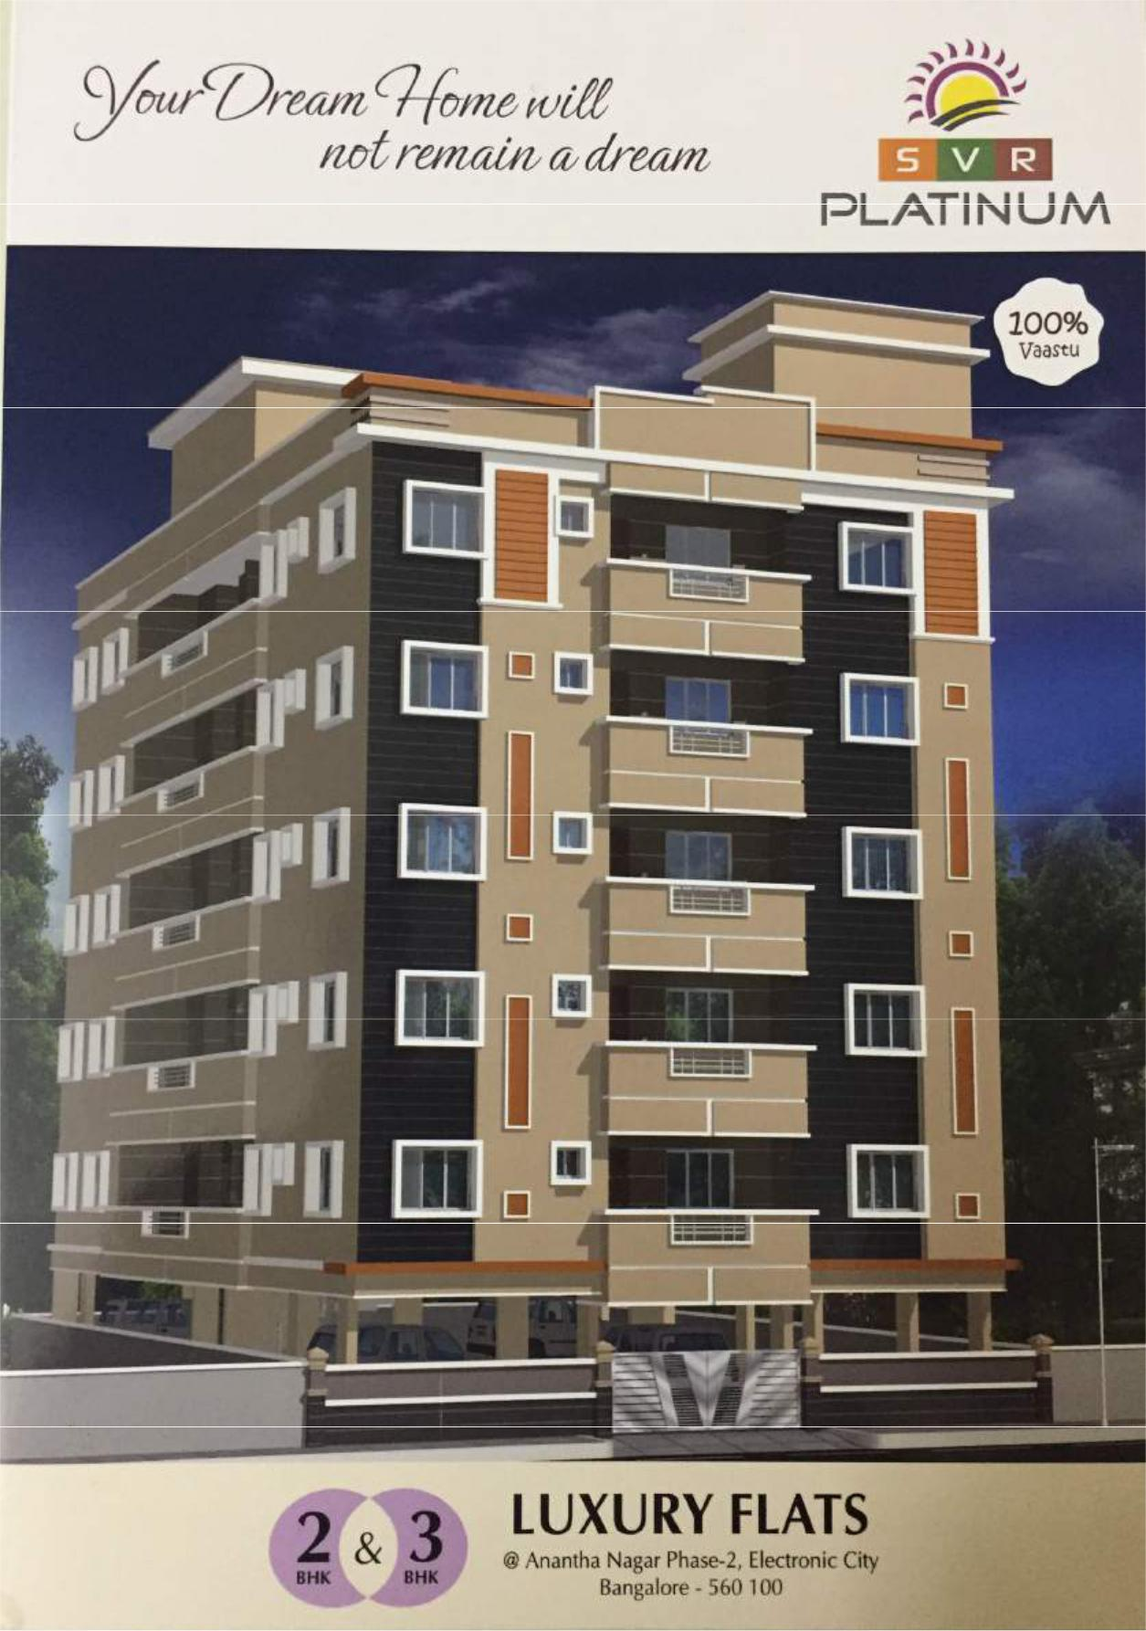

No.72/2, 4th Main road, KSSIDC Industrial Estate, 6TH Block, RajajiNagar, Banglore-560044

SVR Comforts –Electronic City phase-1, Bangalore

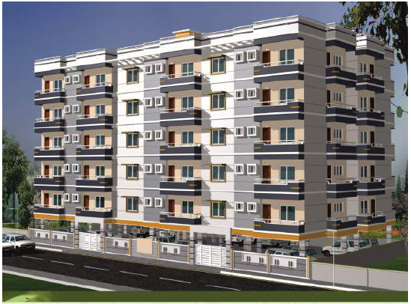

Sree Pranathi Gardens – Rajajinagar, Bangalore

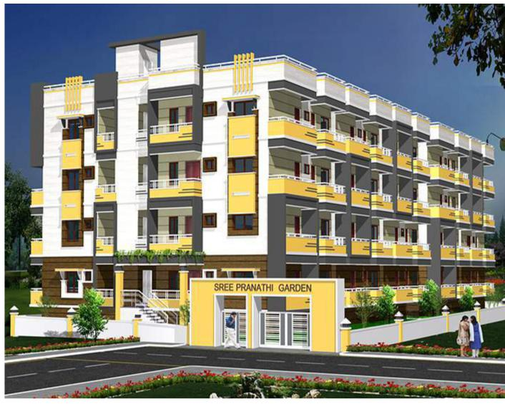
No.72/2, 4th Main road, KSSIDC Industrial Estate, 6TH Block, RajajiNagar, Banglore-560044

Vismaya land development –Maidanahalli, Mysore

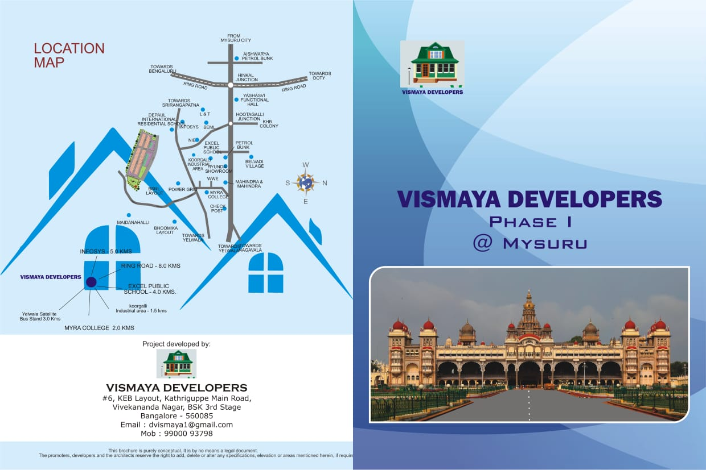

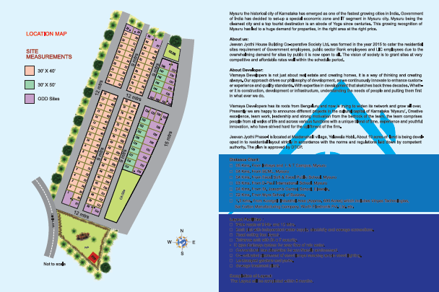

Sahiti Elegance – Hebbgodi, Hosur road, Bangalore

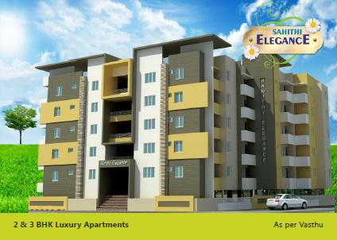

Shree Palace – Electronic city phase-1, Bangalore

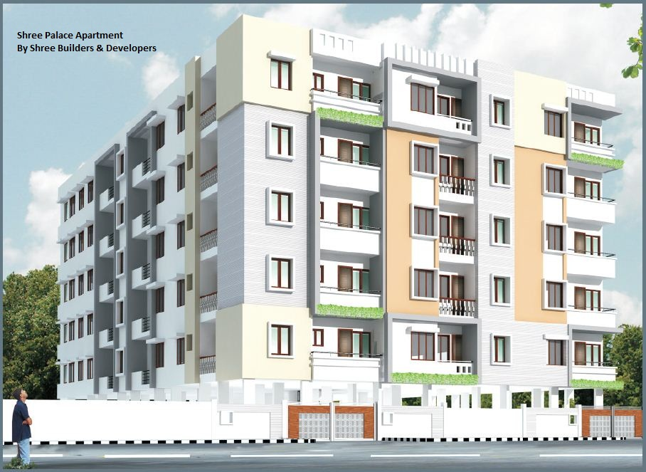

Shree Sai Palace – Doddakallasandra, kanakpura main road

